

SAFETY QUIZ

Answer the following questions by circling the correct answer.

- Which of the following is a potential hazard from dealing with electricity?
  - shock
  - burns
  - nerve damage
  - irregular heartbeat
  - all the above

- When you are working with circuits, it is OK to do what?
  - work on a metal surface
  - have an open beverage nearby
  - work with power supplied to the circuit
  - wear metal jewelry
  - none of the above

- If a person is being shocked by a circuit and is unable to remove himself or herself from the circuit, what is the first thing you should do?
  - tap him or her to see if he or she is OK
  - pull him or her away from the circuit
  - turn off the power to the circuit
  - go and find help

- Supplying power to a circuit should be done when?
  - at the beginning of building the circuit
  - at any point while building the circuit
  - at the end when the circuit is complete

- If an electronic component is damaged, what should you do?
  - use it
  - repair it
  - replace it

LESSON 1

Complete this page after you have built the circuit from Lesson 1.
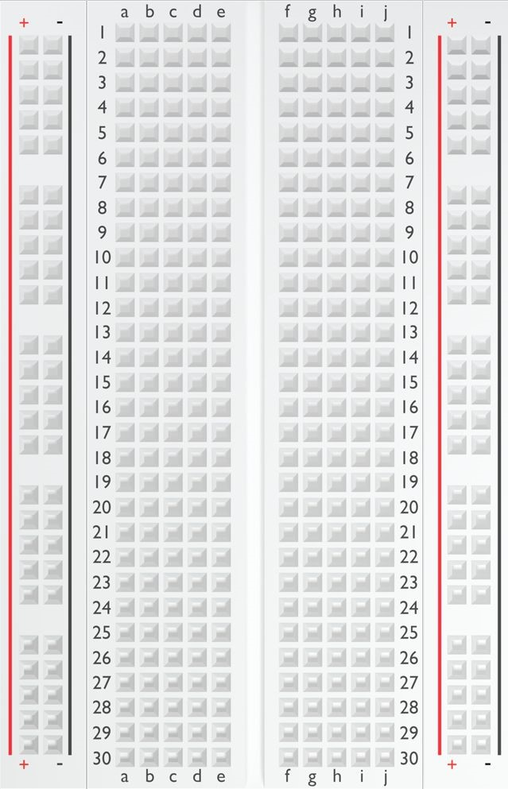
Remove the black wire from the breadboard and

try it in other holes on the breadboard. Circle the

holes on the breadboard at right that complete the

circuit and light the LED.

Why do these holes on the breadboard

light the LED, but other holes don’t?

Replace the 560 Ω resistor with the resistors listed in the following table.
Record your observations of the LED in the table as you try each resistor.

Resistor | 4-Band Color Scheme | 5-Band Color Scheme | Observations
220
1 k
4.7 k
10 k

Replace the resistor with a 560 Ω resistor. Then, replace the yellow LED with a red, green, and blue LED in order. Make sure the anode side of the LED is connected to the resistor and the cathode side is connected to the jumper wire. After each LED lights, swap the positions of the LED’s anode and cathode and observe what happens to the circuit.

What kind of circuit is created when the anode is connected to ground and the cathode is connected to power?

With any color LED connected to the circuit and lit, swap the positions of the red and black wires from the battery.

Does the LED light? Explain your reasoning as to why or why not.

LESSON 2

A. EXTERNAL LED ACTIVITY
Complete this part of the notebook during the External LED activity’s Test and Modify section.

Circuit powered by the Arduino board

Type of Measurement | Units | Measurement When LED Is On | Observation and Notes
Voltage | Volts
Current | Milliamps
Current | Amps
Resistance | Ohms

Resistance of the resistor: _______________ ohms

Resistance of the LED: __________________ ohms

Assume that the total circuit resistance stays the same as what you measured and recorded in the table. Use Ohm’s law to calculate the current in the circuit when a nine-volt battery is supplying the voltage.

Do you think the LED would be brighter when powered by the Arduino board or when powered by the nine-volt battery? Use your current measurements and calculations to justify your answer.

B. SERIES CIRCUIT ACTIVITY
Complete this part of the notebook during the Series Circuit activity’s Test and Modify section.

In a series circuit, what happens when you remove one of the components? Why?

Circuit | Resistor Voltage | LED 1 Voltage | LED 2 Voltage | LED 3 Voltage | Total Voltage
2 LED
3 LED

What happens to the brightness of the LEDs as you add LEDs to the circuit?

How is the brightness of the LED related to the voltage across the LED?

C. PARALLEL CIRCUIT ACTIVITY
Complete this part of the notebook during the Parallel Circuit activity’s Test and Modify section.
In a parallel circuit, what happens when you remove one of the components? Why?

Circuit | LED 1 Voltage | LED 2 Voltage | LED 3 Voltage
2 LED
3 LED

What happens to the brightness of the LEDs as you add LEDs to the circuit?

How many LEDs paths do you think you could add to the circuit and have them all remain lit? Why do you think this?

LESSON 3

Complete the following two pages as you work through Lesson 3.

A. CODE CREATION - Programming a Traffic Light
In the following space, write pseudocode for how you think the traffic light should be programmed.

B. TEST AND MODIFY
Your traffic light is a combination of series and parallel circuits. Explain which components in the circuit are wired in series and why. Then, explain which components are wired in parallel and why.

Use the multimeter to measure the voltage drop over the button and 10K-ohm resistor when the button is in both the up and down positions.

Button Position | Pin 2 Voltage (volts) | Pin 2 State  > 3 volts = HIGH  < 1.5 volts = LOW
Up
Down

In your own words, explain how the push-button circuit reads as either HIGH or LOW on pin 2 of the Arduino board.

LESSON 4

Complete this page during the Test and Modify activity in Lesson 4.

A. CODE CREATION
In the following space, write pseudocode outlining your LED indicator array. Remember that each LED should fade in one at a time based on the value of the potentiometer.

LESSON 5

Complete these pages as you work through Lesson 5.

A. PROJECT IDEAS
Brainstorm a list of possible ideas for how your holiday light circuit will be designed and programmed. Record your ideas in the following space.

B. SCHEMATIC DIAGRAM
Draw a schematic diagram of your holiday light circuit. Make sure that any changes you make to your circuit as you build are also recorded here on your diagram.

C. PSEUDOCODE
Before you begin developing your sketch in the Arduino IDE, write pseudocode that outlines the structure, functions, and commands that will be needed in your sketch to program your light circuit. Record your pseudocode in the following space.

E. ELECTRICAL MEASUREMENTS
Use this table to record electrical measurements and calculations of your circuit. For each component in your circuit, determine the maximum voltage, maximum current, and minimum resistance. You can assume that the minimum resistance of a component occurs when the maximum voltage is passing through it. For each entry in the table, mark whether the amount was measured (M) with the multimeter or calculated (C) with Ohm’s law.
Component | Maximum Voltage |  | Maximum Current |  | Minimum Resistance
Component | M or C | Amount | M or C | Amount | M or C | Amount
Total

*F. DEMONSTRATION (OPTIONAL)
*Complete this section if you were instructed so by an educator
Use the following space to record notes, talking points, or an outline for your demonstration. Use this section as a guide as you present your project to the rest of the class.

*G. PROJECT SCORING RUBRIC (OPTIONAL)
*Complete this section if you were instructed so by an educator

Category | 3 | 2 | 1 | 0 | Tot.
Schematic Diagram | Diagram accurately represents the circuit developed. | Diagram mostly represents the circuit developed but has minor mistakes. | Diagram was attempted and somewhat  represents the circuit developed with some mistakes. | Diagram was not attempted or does not represent the circuit developed.
Circuit  Prototype | Circuit prototype was developed, meeting all criteria and constraints | Circuit prototype was developed, meeting 75% or more of the criteria and constraints. | Circuit prototype was developed, meeting 50% or more of the criteria and constraints. | Circuit prototype was developed, meeting less than 50% of the criteria and constraints.
Code | Code is free of errors, organized, and explained with code comments. | Code is free of errors, is mostly organized, and has some code comments. | Code has minor errors, is not organized, and lacks code comments. | Code has major  errors, is not well organized, and lacks code comments.
Electrical  Measurements | All three of these quantities were measured or calculated correctly in a circuit path: • Total voltage  • Total current • Total resistance | Two of these three quantities were measured or calculated correctly in a circuit path: • Total voltage  - Total current  - Total resistance | One of these three quantities was measured or calculated correctly in a circuit path: • Total voltage  - Total current  - Total resistance | None of these quantities were measured or calculated correctly in a circuit path: • Total voltage  - Total current  - Total resistance
 | Total |  |  |  | /12
*Demonstration | Demonstration | Demonstration | Demonstration | Demonstration met
(​OPTIONAL​) | met three of the following criteria: • Included a working prototype • Included an explanation of the circuit design • Was well organized and delivered | met two of the following criteria: • Included a working prototype • Included an explanation of the circuit design • Was well organized and delivered | met one of the following criteria: • Included a working prototype • Included an explanation of the circuit design • Was well organized and delivered | none of the following criteria:  - Included a working prototype • Included an explanation of the circuit design  - Was well organized and delivered
*Collaboration  (​OPTIONAL​) | Team worked  well together to share the workload. | Team mostly worked well together to share the workload. | Team somewhat worked together, but the workload was not shared equally. | Team did not work together.
 |  |  |  | Total: | /18

Notes and Comments:

LESSON 6

Complete this page during the Test the Circuit section of Lesson 6.

Potentiometer Range | Servo Angle | Distance Traveled | Observations
0 to 115 | 0 to 20 degrees
230 to 285 | 40 to 50 degrees
485 to 545 | 85 to 95 degrees
745 to 800 | 130 to 140 degrees

What conclusions can you draw from the results of your experiment? Is there a relationship between the servo angle and the distance the ball traveled? If so, what is the relationship? Record your conclusions.

What factors would have more of an impact on how far the robot hits, kicks, or throws the ball? Think about how you might be able to control these factors with code in a sketch. Record your ideas.

LESSON 7

Complete this section during the Test and Modify section of the Lesson 7.
Compare the effectiveness of your wiper sketch that used delays to pause the wiper versus the sketch that used the Arduino’s timer and loops to pause the wiper. In your own words, explain the problem with using delays and how this problem was overcome by using the Arduino’s timer and while loops.

Listed below are some pseudocode steps for adding the windshield washer mode to your wiper sketch. Arrange the steps in the most logical order based on your current sketch. To arrange the steps, number each blank from 1 to 8.
____ Declare case 3 for washer mode.
____ When the button is pressed in intermittent mode, change the wiper mode from intermittent to washer mode.
____ When the wipers are done cleaning, turn the fluid and wipers off.
____ Set the pin mode for the blue LED pin as an output.
____ Declare a constant for the blue LED pin.
____ When the button is pressed at the beginning of the main loop. If the wiper is in intermittent mode, change the wiper to washer mode.
____ Move the wipers up and down five times to wash the window.
____ Turn on the blue LED to represent squirting washer fluid on the windshield.

LESSON 8

A. SOUND EXPERIMENT
Complete this section during the Sound Experiment section of Lesson 8.

Rate Variable | Period (s) Rate • 2 / 1000 | Frequency (Hz)  1 / Pitch | Observations
1 | 0.002 | 500
2
3

What conclusions can you draw about the relationship between the frequency of a sound wave and how it sounds?

B. TEST AND MODIFY
Complete this section during the Test and Modify section of Lesson 8.

Note | Key | Analog Value | Voltage
0 | 1
1 | 2
2 | 3
3 | 4
4 | 1
5 | 2
6 | 3
7 | 4

Look at the data from your table. You should notice that the analog value and voltage measurements for Key 1 and Key 2 are close. This could cause a problem with your keyboard where both key buttons play the same note. Record your ideas on how you could improve the keyboard so that it is less likely to play the same note on two different keys.

NOTE FREQUENCIES
This chart shows the frequencies of common notes on a piano.
 | Octave  0 | Octave  1 | Octave  2 | Octave  3 | Octave  4 | Octave  5 | Octave  6 | Octave  7 | Octave  8
C | 16.35 | 32.70 | 65.41 | 130.81 | 261.63 | 523.25 | 1046.50 | 2093.00 | 4186.01
C# | 17.32 | 34.65 | 69.30 | 138.59 | 277.18 | 554.37 | 1108.73 | 2217.46 | 4434.92
D | 18.35 | 36.71 | 73.42 | 146.83 | 293.66 | 587.33 | 1174.66 | 2349.32 | 4698.64
D# | 19.45 | 38.89 | 77.78 | 155.56 | 311.13 | 622.25 | 1244.51 | 2489.02 | 4978.03
E | 20.60 | 41.20 | 82.41 | 164.81 | 329.63 | 659.26 | 1318.51 | 2637.02 | 5274.04
F | 21.83 | 43.65 | 87.31 | 174.61 | 349.23 | 698.46 | 1396.91 | 2793.83 | 5587.65
F# | 23.12 | 46.25 | 92.50 | 185.00 | 369.99 | 739.99 | 1479.98 | 2959.96 | 5919.91
G | 24.50 | 49.00 | 98.00 | 196.00 | 392.00 | 783.99 | 1567.98 | 3135.96 | 6271.93
G# | 25.96 | 51.91 | 103.83 | 207.65 | 415.30 | 830.61 | 1661.22 | 3322.44 | 6644.88
A | 27.50 | 55.00 | 110.00 | 220.00 | 440.00 | 880.00 | 1760.00 | 3520.00 | 7040.00
A# | 29.14 | 58.27 | 116.54 | 233.08 | 466.16 | 932.33 | 1864.66 | 3729.31 | 7458.62
B | 30.87 | 61.74 | 123.47 | 246.94 | 493.88 | 987.77 | 1975.53 | 3951.07 | 7902.13

LESSON 9

A. LIGHT INTENSITY EXPERIMENT
Complete this section during the Light Intensity Experiment section of Lesson 9.

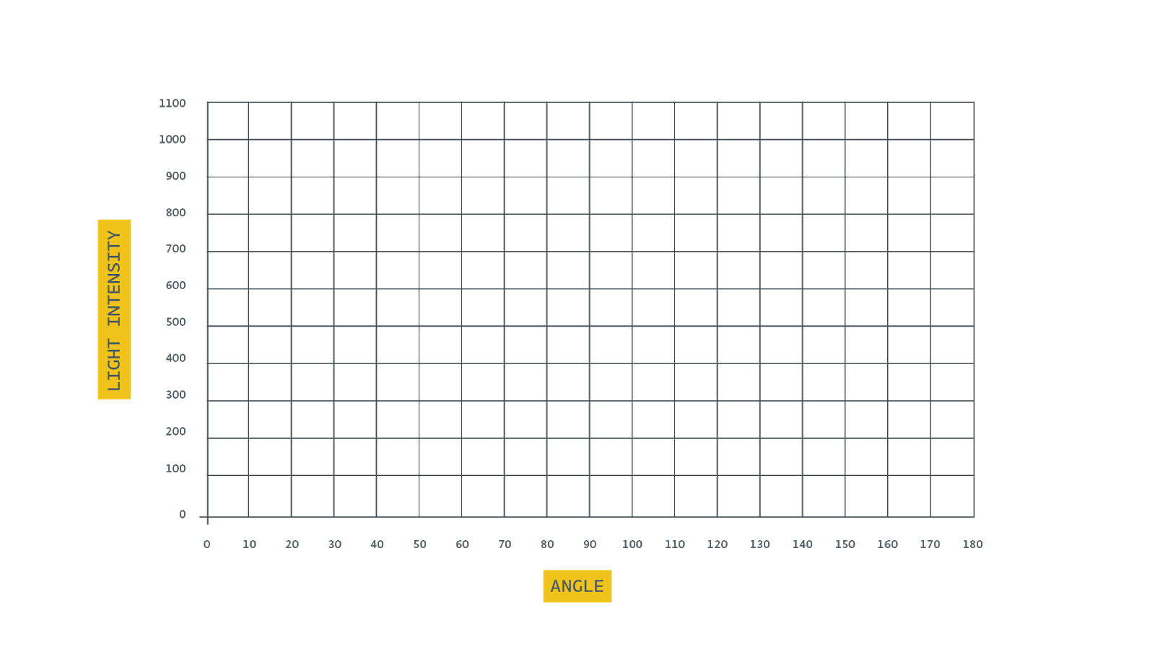
Maximum Intensity Angle:

Maximum Intensity:

Why did the maximum light intensity occur at this angle?

B. TEST AND MODIFY
Complete this section during the Test and Modify section of Lesson 9.

Maximum Intensity Angle:

Maximum Light Intensity:

Minimum Intensity Angle:

Minimum Light Intensity:

LESSON 10
Complete these pages as you work through Lesson 10.

A. PROJECT IDEAS
Brainstorm a list of possible ideas for how your greenhouse climate-control system will be designed and programmed. Record your ideas in the following space.

B. SCHEMATIC DIAGRAM
Draw a schematic diagram of your climate-control circuit. Make sure that any changes you make to your circuit as you build are also recorded here on your diagram.

C. PSEUDOCODE
Before you begin developing your sketch in the Arduino IDE, write pseudocode that outlines the structure, functions, and commands that will be needed in your sketch to program your climate-control circuit. Keep the criteria and constraints of the project in mind as you develop your pseudocode. Record your pseudocode in the following space.

E. MODEL GREENHOUSE
Use the following space to design your greenhouse model. Your design should include sketches of the greenhouse as well as how the control system will work with the model.

*F. DEMONSTRATION (OPTIONAL)
*Complete this section if you were instructed so by an educator
Use the following space to record notes, talking points, or an outline for your demonstration. Use this section as a guide as you present your project to the rest of the class.

*G. PROJECT SCORING RUBRIC (OPTIONAL)
*Complete this section if you were instructed so by an educator
Category | 3 | 2 | 1 | 0 | Total
Schematic Diagram | Diagram accurately represents the circuit developed. | Diagram mostly represents the circuit developed but has minor mistakes. | Diagram was attempted and somewhat  represents the circuit developed with some mistakes. | Diagram was not attempted or does not represent the circuit developed.
Circuit  Prototype | Circuit prototype was developed, meeting all criteria and constraints | Circuit prototype was developed, meeting 75% or more of the criteria and constraints. | Circuit prototype was developed, meeting 50% or more of the criteria and constraints. | Circuit prototype was developed, meeting less than 50% of the criteria and constraints.
Code | Code met all the following criteria: • Code functions and is free of errors and bugs. • Code includes at least one called function.  • Code is clean and well organized and includes code comments. | Code met two of the following criteria:  - Code functions and is free of errors and bugs. • Code includes at least one called function.  - Code is clean and well organized and includes code comments. | Code met one of the following criteria:  - Code functions and is free of errors and bugs. • Code includes at least one called function.  - Code is clean and well organized and includes code comments. | Code met none of the following criteria:  - Code functions and is free of errors and bugs. • Code includes at least one called function.  - Code is clean and well organized and includes code comments.
Model  Greenhouse | Model greenhouse met all the following criteria:  • Model was constructed. • Model shows creativity and ingenuity. • Model incorporates the circuit prototype. | Model greenhouse met two of the following criteria: • Model was constructed. • Model shows creativity and ingenuity. • Model incorporates the circuit prototype. | Model greenhouse met one of the following criteria: • Model was constructed. • Model shows creativity and ingenuity. • Model incorporates the circuit prototype. | Model greenhouse met none the following criteria: • Model was constructed. • Model shows creativity and ingenuity. • Model incorporates the circuit prototype.
Engineering Notebook | All sections of the engineering notebook were completed with reasonable responses. | Most sections (> 66%) of the engineering notebook were completed with reasonable responses. | Some sections (> 33%) of the engineering notebook were completed with reasonable responses. | No sections of the engineering notebook were completed with reasonable responses.
 |  |  |  | Total: | /15
*Demonstratio n  (OPTIONAL) | Demonstration met three of the following criteria: • Included a working prototype of a climate-controlle d greenhouse • Included an explanation of the circuit design  • Was well organized and delivered | Demonstration met two of the following criteria: • Included a working prototype  of a  climate-controlled greenhouse • Included an explanation of the circuit design • Was well organized and delivered | Demonstration met one of the following criteria: • Included a working prototype  of a  climate-controlled greenhouse • Included an explanation of the circuit design • Was well organized and delivered | Demonstration met none of the following criteria: • Included a working prototype  of a  climate-controlled greenhouse • Included an explanation of the circuit design • Was well organized and delivered
*Collaboration  (OPTIONAL) | Team worked  well together to share the workload. | Team mostly worked well together to share the workload. | Team somewhat worked together, but the workload was not shared equally. | Team did not work together.
 |  |  |  | Total: | /21

KEYS & SOLUTIONS
SAFETY QUIZ

1. Which of the following is a potential hazard from dealing with electricity?
- shock
- burns
- nerve damage
- irregular heartbeat

e. all the above

All these are potential dangers when working with electricity. Of course, the more current and voltage, the higher the safety risk.

2. When you are working with circuits, it is OK to do what?
- work on a metal surface
- have an open beverage nearby
- work with power supplied to the circuit
- wear metal jewelry

e. none of the above

When you work with circuits, you should minimize the risk of electricity passing from the circuit to you. This includes working on an insulated surface and removing all metal jewelry that could contact the circuit. You should always keep the work surface clean. Beverages and other liquids should be kept clear of the work area to avoid
spills.
When you are working on a circuit, never work on it with power supplied to the circuit.
Supplying power should be the last step in completing the circuit.

3. If a person is being shocked by a circuit and is unable to remove himself or herself from the circuit, what is the first thing you should do?
- tap him or her to see if he or she is OK
- pull him or her away from the circuit

c. turn off the power to the circuit
d. go and find help

When a person is “frozen” to a circuit and cannot remove himself or herself from the circuit, do not touch the person. Otherwise, the electricity could pass to you. First, you should try to cut power to the circuit. If you are unable to cut power, then try to use an insulated tool such as a wooden broomstick to pry the person from the circuit. When the person is free from the electric current, assess the situation and call for help if needed.

4. Supplying power to a circuit should be done when?
- at the beginning of building the circuit
- at any point while building the circuit

c. at the end when the circuit is complete

Always supply power to the circuit after all other components are wired. Supplying power to the circuit should be the last step in completing the circuit. When you are working on a circuit, always cut power to the circuit first.

5. If an electronic component is damaged, what should you do?
- use it
- repair it
- replace it

Never use broken or damaged components. Find a replacement to use.

LESSON 1 KEYS
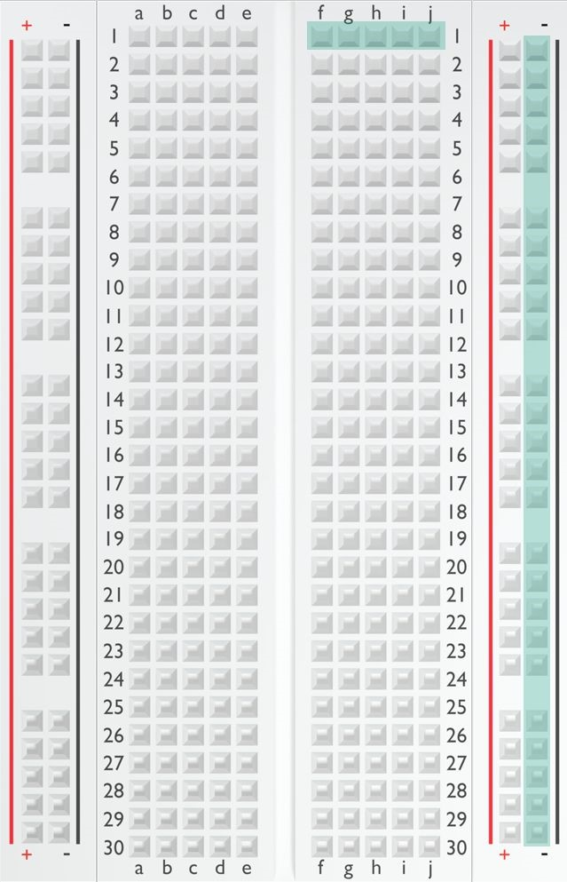
Remove the black wire from the breadboard and

try it in other holes on the breadboard. Circle the

holes on the breadboard at right that complete the

circuit and light the LED.

See highlighted holes on the breadboard at right.

Why do these holes on the breadboard

light the LED, but other holes don’t?

The horizontal holes (1f-1j) are all

connected on the underside of the

breadboard. The vertical holes are all

connected on the underside of the

breadboard, and there is a jumper wire

between the horizontal holes in row 1 and

the vertical holes.

Replace the 560 Ω resistor with the resistors listed in the following table.
Record your observations of the LED in the table as you try each resistor.

Resistor | 4-Band Color Scheme | 5-Band Color Scheme | Observations
220 |  |  | We should observe that the higher the resistance, the dimmer the LED becomes. This is because the current is inversely proportional to resistance. The higher the resistance, the less current can pass through the LED.
1 k
4.7 k
10 kΩ

Replace the resistor with a 560 Ω resistor. Then, replace the yellow LED with a red, green, and blue LED in order. Make sure the anode side of the LED is connected to the resistor and the cathode side is connected to the jumper wire. After each LED lights, swap the positions of the LED’s anode and cathode and observe what happens to the circuit.

What kind of circuit is created when the anode is connected to ground and the cathode is connected to power?

With the LED’s anode and cathode reversed, the circuit is an open circuit because current cannot flow through the LED. An LED is a diode that allows electricity to flow in only one direction.

With any color LED connected to the circuit and lit, swap the positions of the red and black wires from the battery.

Does the LED light? Explain your reasoning as to why or why not.

The LED should not light. Switching the direction of flow through the circuit creates an open circuit at the LED. To resolve the problem, switch the terminals of the LED so that the anode is connected to the jumper wire and the cathode is connected to the resistor

LESSON 2 KEYS

A. EXTERNAL LED ACTIVITY
Solutions for External LED activity’s Test and Modify section.

Circuit powered by the Arduino board

Type of Measurement | Units | Measurement When LED Is On | Observation and Notes
Voltage | Volts | ≈ 4.8 volts
Current | Milliamps | ≈ 12.6 milliamps
Current | Amps | ≈ 0.0126 amps
Resistance | Ohms | ≈ 381 ohms

Resistance of the resistor: | ​≈ 219 ohms​
Resistance of the LED: | ≈ 162​ ohms

Assume that the total circuit resistance stays the same as what you measured and recorded in the table. Use Ohm’s law to calculate the current in the circuit when a nine-volt battery is supplying the voltage.

Current= Voltage ÷ Resistance

Current= 9 volts ÷ ≈ 381 ohms
Current= ≈ 0.024 amps
Current= ≈ 24 milliamps

Do you think the LED would be brighter when powered by the Arduino board or when powered by the nine-volt battery? Use your current measurements and calculations to justify your answer.

The LED should be brighter when powered by the nine-volt battery because it has more current flowing through it.

B. SERIES CIRCUIT ACTIVITY
Solutions for Series Circuit activity’s Test and Modify section.

In a series circuit, what happens when you remove one of the components? Why?

In a series circuit, there is only one path for the current to flow through, so if we remove a component, it breaks the circuit and current can’t flow through any of the components.

Circuit | Resistor Voltage | LED 1 Voltage | LED 2 Voltage | LED 3 Voltage | Total Voltage
2 LED | ≈ 1.42 volts | ≈ 1.83 volts | ≈ 1.83 volts |  | ≈ 5.08 volts
3 LED | ≈ 0.16 volts | ≈ 1.65 volts | ≈ 1.65 volts | ≈ 1.65 volts | ≈ 5.11 volts

What happens to the brightness of the LEDs as you add LEDs to the circuit?

In a series circuit, as we add LEDs to the circuit, the LEDs become dimmer. This is because the voltage gets split between the LEDs in the circuit, giving each LED less voltage.

How is the brightness of the LED related to the voltage across the LED?

The higher the voltage across an LED, the brighter the LED will be.

C. PARALLEL CIRCUIT ACTIVITY
Solutions for Parallel Circuit activity’s Test and Modify section.
In a parallel circuit, what happens when you remove one of the components? Why?

In a parallel circuit, there are multiple paths for current to flow through. If we remove a component from one path, the components in the other paths will continue to work.

Circuit | LED 1 Voltage | LED 2 Voltage | LED 3 Voltage
2 LED | ≈ 1.94 volts | ≈ 1.94 volts
3 LED | ≈ 1.94 volts | ≈ 1.94 volts | ≈ 1.94 volts

What happens to the brightness of the LEDs as you add LEDs to the circuit?

In a parallel circuit, as we add LEDs to the circuit, the LEDs should stay about the same brightness. This is because each path gets the full voltage being supplied by the source. As long as the components of each path are the same, the LED voltage and, therefore, brightness should be about the same.
How many LEDs paths do you think you could add to the circuit and have them all remain lit? Why do you think this?
This question is designed to think and therefore doesn’t have a wrong answer as long as they can justify their response. However, if we read the LEDs in Parallel section at the end of Lesson 2, they will learn that in a parallel circuit, current is the limiting factor rather than voltage. The Arduino board can supply up to only 500 milliamps of current, limiting the number of LEDs by the amount of current they draw.

LESSON 3 KEYS

A. CODE CREATION - Programming a Traffic Light
In the following space, write pseudocode for how you think the traffic light should be programmed.
Answers will vary depending on the order we turn the lights on and how long we leave them on. One example would look something like this:
- The red light should turn on while the yellow and green lights turn off.
- The red light should stay on for 15 seconds.
- The green light should turn on while the red and yellow lights turn off.
- The green light should stay on for 15 seconds.
- The yellow light should turn on while the green and red lights turn off.
- The yellow light should stay on for 3 seconds.
- Go back to the beginning and repeat the commands.

B. TEST AND MODIFY
Your traffic light is a combination of series and parallel circuits. Explain which components in the circuit are wired in series and why. Then, explain which components are wired in parallel and why.

The three LED paths are parallel circuits. Each path is controlled by a different pin on the Arduino board. Each path will receive the full 5 volts of electricity when the pin is set to HIGH. Within each path, the LED and 220-ohm resistor are wired in series because there is a single path from the pin to the negative terminal, where the paths join back together and are connected to ground. The push button and 10K-ohm resistor connected to pin 2 are also wired in parallel. Pin 2 can receive a HIGH or LOW signal from one of the two paths depending whether the button is pressed.

Use the multimeter to measure the voltage drop over the button and 10K-ohm resistor when the button is in both the up and down positions.

Button Position | Pin 2 Voltage (volts) | Pin 2 State  > 3 volts = HIGH  < 1.5 volts = LOW
Up | 0 volts | LOW
Down | ≈ 5.11 volts | HIGH

In your own words, explain how the push-button circuit reads as either HIGH or LOW on pin 2 of the Arduino board.

Answers will vary, but we should explain the following: Pin 2 is connected to 5 volts through the push-button switch. When the switch is down, current flows through the switch and pin 2 reads the full 5 volts sent from the 5V pin. Five volts is greater than the 3-volt threshold, so pin 2 assigns a value of HIGH to the state of the pin.

Pin 2 is also connected to ground through the 10K-ohm resistor (pull-down resistor). When the switch is up, current can’t flow through the switch; instead, current is drawn from ground. However, the 10K-ohm resistor cancels out any voltage from ground and brings the voltage very low to zero or near zero. This low voltage is less than the
1.5-volt threshold, so pin 2 assigns a value of LOW to the state of the pin.

LESSON 4 KEYS

Solutions for Test and Modify activity in Lesson 4.

A. CODE CREATION
In the following space, write pseudocode outlining your LED indicator array. Remember that each LED should fade in one at a time based on the value of the potentiometer.
Pseudocode will vary from project to project. Some will have more detail than others.
Some pseudocode might have wrong logic or appear to be in the wrong order. This is OK. The point of writing pseudocode is to help think through the problem and start working toward a solution with code. There isn’t necessarily a wrong or right answer. To evaluate the entries, organize thoughts and put them into code. Below are some
tips:
- List the tasks that the program needs to do.
- Arrange the list of tasks in an appropriate sequence or algorithm.
- Use indention to organize commands within functions or code blocks just like you would in the programming language. This makes the pseudocode easier to read.
- Be detailed. Don’t leave steps out or be vague with descriptions.
- Write pseudocode in everyday language, not programming language. It should be readable by non-programmers.

Here is an example of what pseudocode for this activity might look like:
Declare readValue variable.
Declare writeValue variable.
Start setup section.
Declare 3 digital pin outputs.
Start the serial monitor.
End the setup section.
Start the main loop.
Set the readValue variable to the value from the potentiometer connected to pin A0.
Set the writeValue variable to the readValue ÷ 4.
If the readValue is in the low range, then
Turn off all LEDs.
If the readValue is in the low to midrange, then
Fade in the first LED based on the writeValue variable and leave other LEDs off.
If the readValue is in the mid- to high range, then
Fade in the first two LEDs based on the writeValue variable and leave the other LED off.
If the readValue is in the high range, then
Fade in all three LEDs based on the writeValue variable.
Print the readValue variable in the serial monitor.
Print the writeValue variable in the serial monitor. Delay for a short time. End the main loop.

LESSON 5 KEYS

A. PROJECT IDEAS
Brainstorm a list of possible ideas for how your holiday light circuit will be designed and programmed. Record your ideas in the following space.
Ideas can include:
- Number and colors of LEDs to be used
- Type of circuits (series or parallel) to be wired
- What the potentiometer will control
- Whether the LEDs will flash, fade, or have other behaviors

B. SCHEMATIC DIAGRAM
Draw a schematic diagram of your holiday light circuit. Make sure that any changes you make to your circuit as you build are also recorded here on your diagram.
The schematic diagram will vary by project. We do not have to draw the entire Arduino board; We can just use a rectangle to represent the board. However, we should indicate what pins on the board are being used and how they are connected to components of the circuit.

C. PSEUDOCODE
Before you begin developing your sketch in the Arduino IDE, write pseudocode that outlines the structure, functions, and commands that will be needed in your sketch to program your light circuit. Record your pseudocode in the following space.
Pseudocode will vary depending on how each one designs their circuit.

E. ELECTRICAL MEASUREMENTS
Use this table to record electrical measurements and calculations of your circuit. For each component in your circuit, determine the maximum voltage, maximum current, and minimum resistance. You can assume that the minimum resistance of a component occurs when the maximum voltage is passing through it. For each entry in the table, mark whether the amount was measured (M) with the multimeter or calculated (C) with Ohm’s law.

Component | Maximum Voltage |  | Maximum Current |  | Minimum Resistance
Component | M or C | Amount | M or C | Amount | M or C | Amount
Components and values in the table will vary depending on the number of LEDs, color of LEDS, and types of resistor used in the circuit. However, if completed correctly, we should be taking these measurements for a single circuit path that is controlled by one pin of the Arduino board. The components in the path will most likely be wired in series, which means:
- The total voltage is the sum of the voltage drops for all components in the path and should be about 5 volts.
- The total current should be less than 25 milliamps (according to the criteria and constraints of the project) and is the same throughout the circuit path.
- The total resistance should be the sum of the resistances for each component in the path. This number should be calculated from Ohm’s law because the individual resistances of the LEDs in the path cannot be measured. After the total resistance is calculated, we can work backwards from the total to determine the individual resistances of the LEDs.
○ Note: Actually, if there are more than one LED in the path, the resistance of each LED will vary depending on color and minor differences from LED to LED. Determining the exact resistance of each LED isn’t important for this activity.

Total |  | ≈ 5 volts |  | < 0.025 amps, or 25 milliamps |  | > 220 ohms

*F. DEMONSTRATION (OPTIONAL)
*Complete this section if you were instructed so by an instructor
Use the following space to record notes, talking points, or an outline for your demonstration. Use this section as a guide as you present your project to the rest of the class.
In our demonstration, we should:
- Show your working prototype.
- Explain how your circuit works and how it can be manipulated using the push button and potentiometer.
- Identify what parts of the circuit are wired in series or parallel.
- Discuss some of the decisions you had to make while building and coding the circuit.
- Explain why you made decisions the way you did.

*G. PROJECT SCORING RUBRIC
In case you self-evaluate your project, feel free to skip the last two categories (optional).

Category | 3 | 2 | 1 | 0 | Tot.
Schematic Diagram | Diagram accurately represents the circuit developed. | Diagram mostly represents the circuit developed but has minor mistakes. | Diagram was attempted and somewhat  represents the circuit developed with some mistakes. | Diagram was not attempted or does not represent the circuit developed.
Circuit  Prototype | Circuit prototype was developed, meeting all criteria and constraints | Circuit prototype was developed, meeting 75% or more of the criteria and constraints. | Circuit prototype was developed, meeting 50% or more of the criteria and constraints. | Circuit prototype was developed, meeting less than 50% of the criteria and constraints.
Code | Code is free of | Code is free of | Code has minor | Code has major
 | errors, organized, and explained with code comments. | errors, is mostly organized, and has some code comments. | errors, is not organized, and lacks code comments. | errors, is not well organized, and lacks code comments.
Electrical  Measurements | All three of these quantities were measured or calculated correctly in a circuit path: • Total voltage  • Total current • Total resistance | Two of these three quantities were measured or calculated correctly in a circuit path: • Total voltage  - Total current  - Total resistance | One of these three quantities was measured or calculated correctly in a circuit path: • Total voltage  - Total current  - Total resistance | None of these quantities were measured or calculated correctly in a circuit path: • Total voltage  - Total current  - Total resistance
 |  |  |  | Total | /12
*Demonstration  (​OPTIONAL​) | Demonstration met three of the following criteria: • Included a working prototype • Included an explanation of the circuit design • Was well organized and delivered | Demonstration met two of the following criteria: • Included a working prototype • Included an explanation of the circuit design • Was well organized and delivered | Demonstration met one of the following criteria: • Included a working prototype • Included an explanation of the circuit design  • Was well organized and delivered | Demonstration met none of the following criteria: • Included a working prototype • Included an explanation of the circuit design  • Was well organized and delivered
*Collaboration*  (​OPTIONAL​) | Team worked well together to share the workload. | Team mostly worked well together to share the workload. | Team somewhat worked together, but the workload was not shared equally. | Team did not work together.
 |  |  |  | Total: | /18

LESSON 6 KEYS

Potentiometer Range | Servo Angle | Distance Traveled | Observations
0 to 115 | 0 to 20 degrees | Answers will vary depending on the friction the ball is  rolling on. However,  there should not be a  significant difference in the distance the ball rolls. How much of a windup or  follow-through the  robot has should have very little impact on  how far the ball travels.  The speed at which the ball is struck would have the greatest impact on distance. | We should notice that even when the robot  has more of a windup  or follow-through, the speed of the servo  remains the same. In  other words, the robot servo rotates at the  same speed no matter how far it has to move.
230 to 285 | 40 to 50 degrees
485 to 545 | 85 to 95 degrees
745 to 800 | 130 to 140 degrees

What conclusions can you draw from the results of your experiment? Is there a relationship between the servo angle and the distance the ball traveled? If so, what is the relationship? Record your conclusions.

Although the data can be skewed by factors outside their control, we should find that there is no relationship between the angle that the servo rotates and the distance the ball travels. This is because the servo travels at the same speed no matter how far it rotates.

What factors would have more of an impact on how far the robot hits, kicks, or throws the ball? Think about how you might be able to control these factors with code in a sketch. Record your ideas.

Answers will vary. This question is more about getting to speculate and think through the problem than it is coming up with a correct answer.

The speed that the ball is struck with has the greatest impact on how far the ball travels. However, servo speed can be difficult to control. There are no commands in the Servo library for controlling the servo’s speed. It is possible using delays (or other more complicated methods) to slow the servo down, but the servo cannot be sped up.

To better control speed, replacing the servo with a DC motor might be a good option. However, unless the DC motor has encoder sensors, it is almost impossible to precisely control its position like you can a standard 180-degree servo.

Another way to increase the distance the ball travels would be to increase the lever length of the arm that strikes the ball. The farther away the striking area is from the center of rotation, the faster the arm is moving. This is why golfers, baseball players, hockey players, and others often want to use the longest equipment that they can control.

LESSON 7 KEYS

Compare the effectiveness of your wiper sketch that used delays to pause the wiper versus the sketch that used the Arduino’s timer and loops to pause the wiper. In your own words, explain the problem with using delays and how this problem was overcome by using the Arduino’s timer and while loops.
Answers will vary. However, responses should indicate that the wiper circuit is much more effective when using the timer and loops as compared to using delays. When using a delay, the Arduino board can’t perform any functions or commands until the delay is over. A delay simply pauses the Arduino board for a designated amount of time. By using the Arduino’s timer and loops, the Arduino board can perform other tasks and processes while waiting. In this case, the Arduino board can check to see if the on/off button has been pressed.
Listed below are some pseudocode steps for adding the windshield washer mode to your wiper sketch. Arrange the steps in the most logical order based on your current sketch. To arrange the steps, number each blank from 1 to 8.
3 Declare case 3 for washer mode.
7 When the button is pressed in intermittent mode, change the wiper mode from intermittent to washer mode.
6 When the wipers are done cleaning, turn the fluid and wipers off.
2 Set the pin mode for the blue LED pin as an output.
1 Declare a constant for the blue LED pin.
8 When the button is pressed at the beginning of the main loop. If the wiper is in intermittent mode, change the wiper to washer mode.
5 Move the wipers up and down five times to wash the window.
4 Turn on the blue LED to represent squirting washer fluid on the windshield.

The most logical order is shown above. If you come up with a different order, try to justify your reasoning.

LESSON 8 KEYS

A. SOUND EXPERIMENT

Rate Variable | Period (s) Rate • 2 / 1000 | Frequency (Hz)  1 / Pitch | Observations
1 | 0.002 | 500 | Observations will vary, but we should indicate that the tone is a mid-range pitch with a moderate volume.
2 | 0.004 | 250 | Observations will vary, but we should indicate that the tone is lower than the previous pitch and the volume is about the same.
3 | 0.006 | ≈ 167 | Observations will vary, but we should indicate that the tone is the lowest of the three pitches and that the volume is perhaps a little quieter but not by much.

What conclusions can you draw about the relationship between the frequency of a sound wave and how it sounds?

We should conclude that the lower the frequency of the sound wave, the lower the pitch will be.

B. TEST AND MODIFY
Solutions for Test and Modify section of Lesson 8.

Note | Key | Analog Value | Voltage
0 | 1 | ≈ 1020 | ≈ 5.14
1 | 2 | ≈ 999 | ≈ 5.03
2 | 3 | ≈ 696 | ≈ 3.50
3 | 4 | ≈ 511 | ≈ 2.57
4 | 1 | ≈ 1018 | ≈ 5.13
5 | 2 | ≈ 998 | ≈ 5.02
6 | 3 | ≈ 695 | ≈ 3.49
7 | 4 | ≈ 511 | ≈ 2.57

Look at the data from your table. You should notice that the analog value and voltage measurements for Key 1 and Key 2 are close. This could cause a problem with your keyboard where both key buttons play the same note. Record your ideas on how you could improve the keyboard so that it is less likely to play the same note on two different keys.

Answers will vary, but we should realize that the more resistance added to the circuit, the lower the analog value and voltage measurement. Therefore, one way to separate the analog values more would be to replace the 220-ohm resistor in the circuit with a larger resistor, such as a 560-ohm or even the 1K-ohm resistor.

Another solution would be to change the threshold values in the Arduino sketch so that they are exactly between the analog values shown in the table for two different keys. For example, you could set the threshold value to distinguish between Key 1 and Key 2 at 1010 (halfway between 1020 and 999).

NOTE FREQUENCIES
This chart shows the frequencies of common notes on a piano.
 | Octave  0 | Octave  1 | Octave  2 | Octave  3 | Octave  4 | Octave  5 | Octave  6 | Octave  7 | Octave  8
C | 16.35 | 32.70 | 65.41 | 130.81 | 261.63 | 523.25 | 1046.50 | 2093.00 | 4186.01
C# | 17.32 | 34.65 | 69.30 | 138.59 | 277.18 | 554.37 | 1108.73 | 2217.46 | 4434.92
D | 18.35 | 36.71 | 73.42 | 146.83 | 293.66 | 587.33 | 1174.66 | 2349.32 | 4698.64
D# | 19.45 | 38.89 | 77.78 | 155.56 | 311.13 | 622.25 | 1244.51 | 2489.02 | 4978.03
E | 20.60 | 41.20 | 82.41 | 164.81 | 329.63 | 659.26 | 1318.51 | 2637.02 | 5274.04
F | 21.83 | 43.65 | 87.31 | 174.61 | 349.23 | 698.46 | 1396.91 | 2793.83 | 5587.65
F# | 23.12 | 46.25 | 92.50 | 185.00 | 369.99 | 739.99 | 1479.98 | 2959.96 | 5919.91
G | 24.50 | 49.00 | 98.00 | 196.00 | 392.00 | 783.99 | 1567.98 | 3135.96 | 6271.93
G# | 25.96 | 51.91 | 103.83 | 207.65 | 415.30 | 830.61 | 1661.22 | 3322.44 | 6644.88
A | 27.50 | 55.00 | 110.00 | 220.00 | 440.00 | 880.00 | 1760.00 | 3520.00 | 7040.00
A# | 29.14 | 58.27 | 116.54 | 233.08 | 466.16 | 932.33 | 1864.66 | 3729.31 | 7458.62
B | 30.87 | 61.74 | 123.47 | 246.94 | 493.88 | 987.77 | 1975.53 | 3951.07 | 7902.13

LESSON 9 KEYS

A. LIGHT INTENSITY EXPERIMENT
Solutions for Light Intensity Experiment section of Lesson 9.

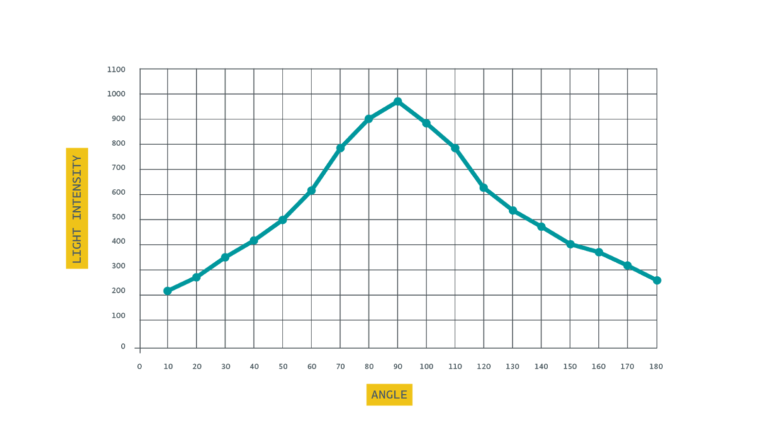
Graphs will vary depending on the light in the room and how we hold the servo. Most rooms will have a bell-shaped curve where the brightest light intensity is overhead while the lowest light intensity is at 0 or 180 degrees. Some graphs might have two peaks if there are multiple light sources in the room.

Maximum Intensity Angle: ​Answers will vary but should be close to 90 degrees.

Maximum Intensity: ​Answers will vary depending on the light in the room.

Why did the maximum light intensity occur at this angle?

Answers should indicate that the brightest source of light in the room was at that angle. Depending on the room, the light source might be an overhead light, a desk lamp, a computer screen, or a window with sunlight shining through.

B. TEST AND MODIFY
Solution for Test and Modify section of Lesson 9.

Maximum Intensity Angle:​ Answers will vary but should be close to 90 degrees.

Maximum Light Intensity: ​Answers will vary depending on the lin the room.

Minimum Intensity Angle: ​Answers will vary but should be close to 0 or 180 degrees.

Minimum Light Intensity: ​Answers will vary depending on the light in the room.

LESSON 10 KEYS

A. PROJECT IDEAS
Brainstorm a list of possible ideas for how your greenhouse climate-control system will be designed and programmed. Record your ideas in the following space.
Ideas can include:
- Number and color of LEDs to be used and what they will be used for.
- How the servo will be used and controlled.
- How the temperature and light sensors will be used and what actions occur based on data from the sensors.
- How input devices such as potentiometers, push buttons, or data from the serial monitor will be used to manually control parts of the circuit.

B. SCHEMATIC DIAGRAM
Draw a schematic diagram of your climate-control circuit. Make sure that any changes you make to your circuit as you build are also recorded here on your diagram.
The schematic diagram will vary by project. We should be familiar with the schematic symbols for each component except for the temperature sensor, which is presented in the Schematic Diagram section of the objectives. We do not have to draw the entire Arduino board; they can just use a rectangle to represent the board. However, they should indicate which pins on the board are being used and how they are connected to components of the circuit.

C. PSEUDOCODE
Before you begin developing your sketch in the Arduino IDE, write pseudocode that outlines the structure, functions, and commands that will be needed in your sketch to program your climate-control circuit. Keep the criteria and constraints of the project in mind as you develop your pseudocode. Record your pseudocode in the following space.
Pseudocode will vary depending on how each team designs their circuit.

E. MODEL GREENHOUSE
Use the following space to design your greenhouse model. Your design should include sketches of the greenhouse as well as how the control system will work with the model.
Model greenhouse designs will vary depending on the materials available and what is used. We should at least draw a sketch that is representative of our model greenhouse and how the climate-control system is incorporated into the model.

*F. DEMONSTRATION (OPTIONAL)
Use the following space to record notes, talking points, or an outline for your demonstration. Use this section as a guide as you present your project to the rest of the class.
In our demonstration, we should:
- Show your working prototype.
- Explain how your circuit works and how it can be manipulated using the push button and potentiometer.
- Identify what parts of the circuit are wired in series or parallel.
- Discuss some of the decisions you had to make while building and coding the circuit.
- Explain why you made decisions the way you did.

*G. PROJECT SCORING RUBRIC (OPTIONAL)
Category | 3 | 2 | 1 | 0 | Tota l
Schematic Diagram | Diagram accurately represents the circuit developed. | Diagram mostly represents the circuit developed but has minor mistakes. | Diagram was attempted and somewhat  represents the circuit developed with some mistakes. | Diagram was not attempted or does not represent the circuit developed.
Circuit  Prototype | Circuit prototype was developed, meeting all criteria and constraints | Circuit prototype was developed, meeting 75% or more of the criteria and constraints. | Circuit prototype was developed, meeting 50% or more of the criteria and constraints. | Circuit prototype was developed, meeting less than 50% of the criteria and constraints.
Code | Code met all the following  criteria:  • Code functions and is free of errors and bugs. • Code includes at least one called function. • Code is clean and well organized and includes code comments. | Code met two of the following criteria:  - Code functions and is free of errors and bugs. • Code includes at least one called function.  - Code is clean and well organized and includes code comments. | Code met one of the following criteria:  - Code functions and is free of errors and bugs. • Code includes at least one called function.  - Code is clean and well organized and includes code comments. | Code met none of the following criteria: • Code functions and is free of errors and bugs.  - Code includes at least one called function.  - Code is clean and well organized and includes code comments.
Model  Greenhouse | Model greenhouse met all the following criteria:  • Model was constructed. • Model shows creativity and ingenuity. • Model incorporates the  circuit prototype. | Model greenhouse met two of the following criteria: • Model was constructed. • Model shows creativity and ingenuity. • Model incorporates the circuit prototype. | Model greenhouse met one of the following criteria: • Model was constructed. • Model shows creativity and ingenuity. • Model incorporates the circuit prototype. | Model greenhouse met none the following criteria: • Model was constructed. • Model shows creativity and ingenuity.  • Model incorporates the circuit prototype.
Logbook | All sections of the engineering notebook were completed with reasonable responses. | Most sections (> 66%) of the engineering notebook were completed with reasonable responses. | Some sections (> 33%) of the engineering notebook were completed with reasonable responses. | No sections of the engineering notebook were completed with reasonable responses.
 |  |  |  | Total: | /15
*Demonstration  (OPTIONAL) | Demonstration met three of the following criteria: • Included a working prototype of a climate-controll ed greenhouse • Included an explanation of the circuit design • Was well organized and delivered | Demonstration met two of the following criteria: • Included a working prototype  of a  climate-controlled greenhouse • Included an explanation of the circuit design • Was well organized and delivered | Demonstration met one of the following criteria: • Included a working prototype  of a  climate-controlled greenhouse • Included an explanation of the circuit design • Was well organized and delivered | Demonstration met  none of the following criteria:  - Included a working prototype of a climate-controlled greenhouse • Included an explanation of the circuit design  - Was well organized and delivered
*Collaboration  (OPTIONAL) | Team worked  well together to share the workload. | Team mostly worked well together to share the workload. | Team somewhat worked together, but the workload was not shared equally. | Team did not work together.
 |  |  |  | Total: | /21

Notes and Comments:


DEVELOPED BY

